General idea:

1) Drawing from Weeks and Lane’s (2020) ecological model, develop indicators at each “layer” of influence: cognitive, id/demographics, environmental perceptions, motivations, social networks, and media systems.

2) Fit both “trait” models with relatively stable habits/characteristics and “state” models with more ephemeral, context-dependent variables. In this case, “trait” models contain normal survey measures while “state” models contain variables from the rolling sections (i.e., responses to the screenshot stimuli).

**Trait Models**

**Model 1: Outcome = incidental news exposure (political info exposure * incidentality)**

**OLS used, DV does not vary across waves**

**Significant predictors include: knowledge, news media literacy, frequency of social media use, age, gender, race, education, purposeful news use, following accounts for news, network diversity, and group membership**

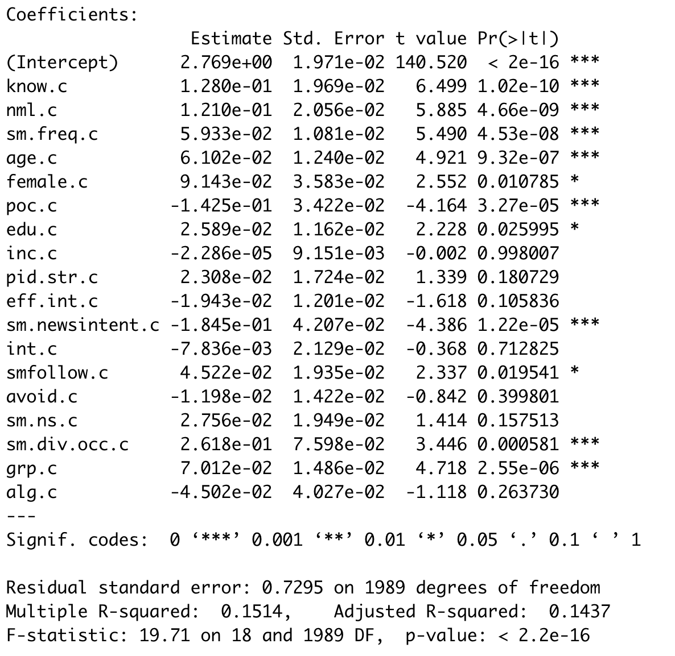

**Model 2: Outcome = incidental news exposure (social media news use * incidentality)**

**OLS used, DV does not vary across waves**

**Significant predictors include; knowledge, news media literacy, frequency of social media use, purposeful news use, interest, network size, network diversity, and group membership**

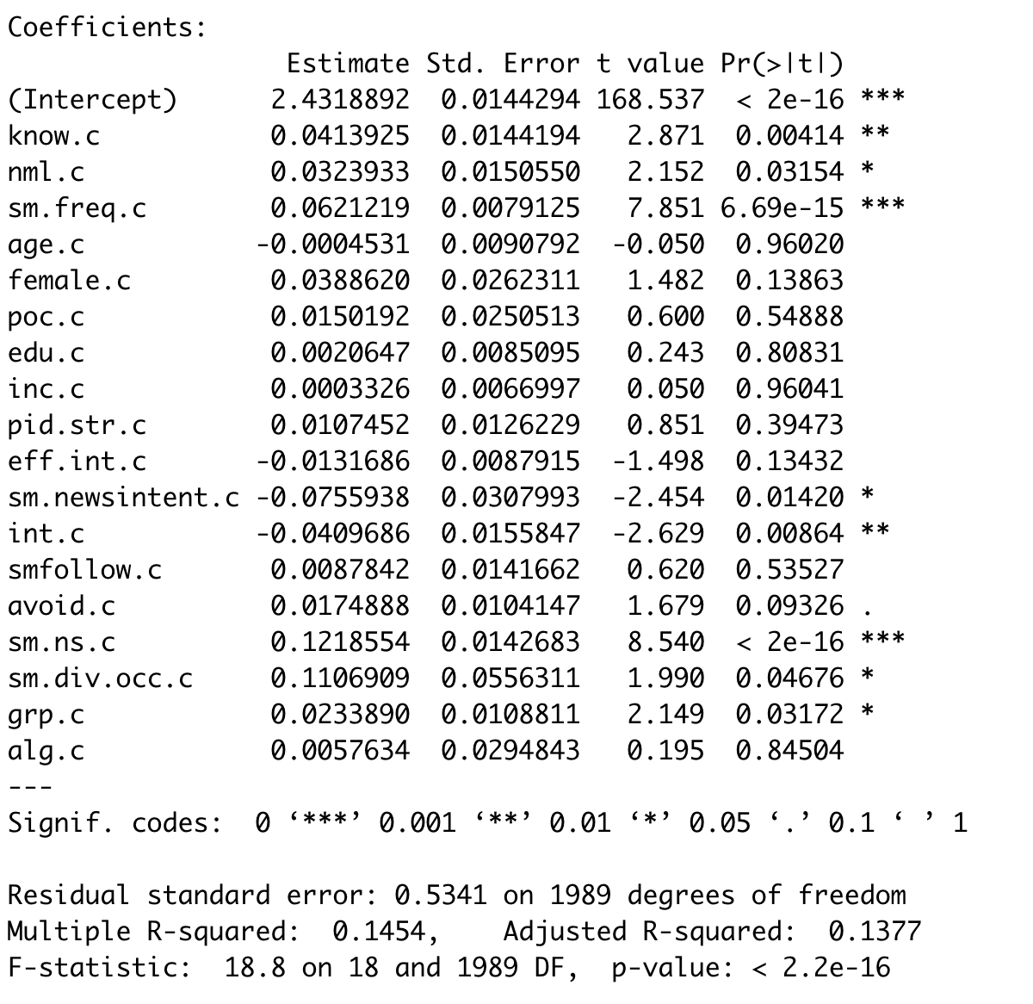

**Model 3: Outcome = social media news use**

**MLM used, DV varies across waves**

**Significant predictors include: frequency of social media use, age, gender, purposeful news use, following accounts for news, news avoidance, network size, network diversity, and algorithmic categorization**

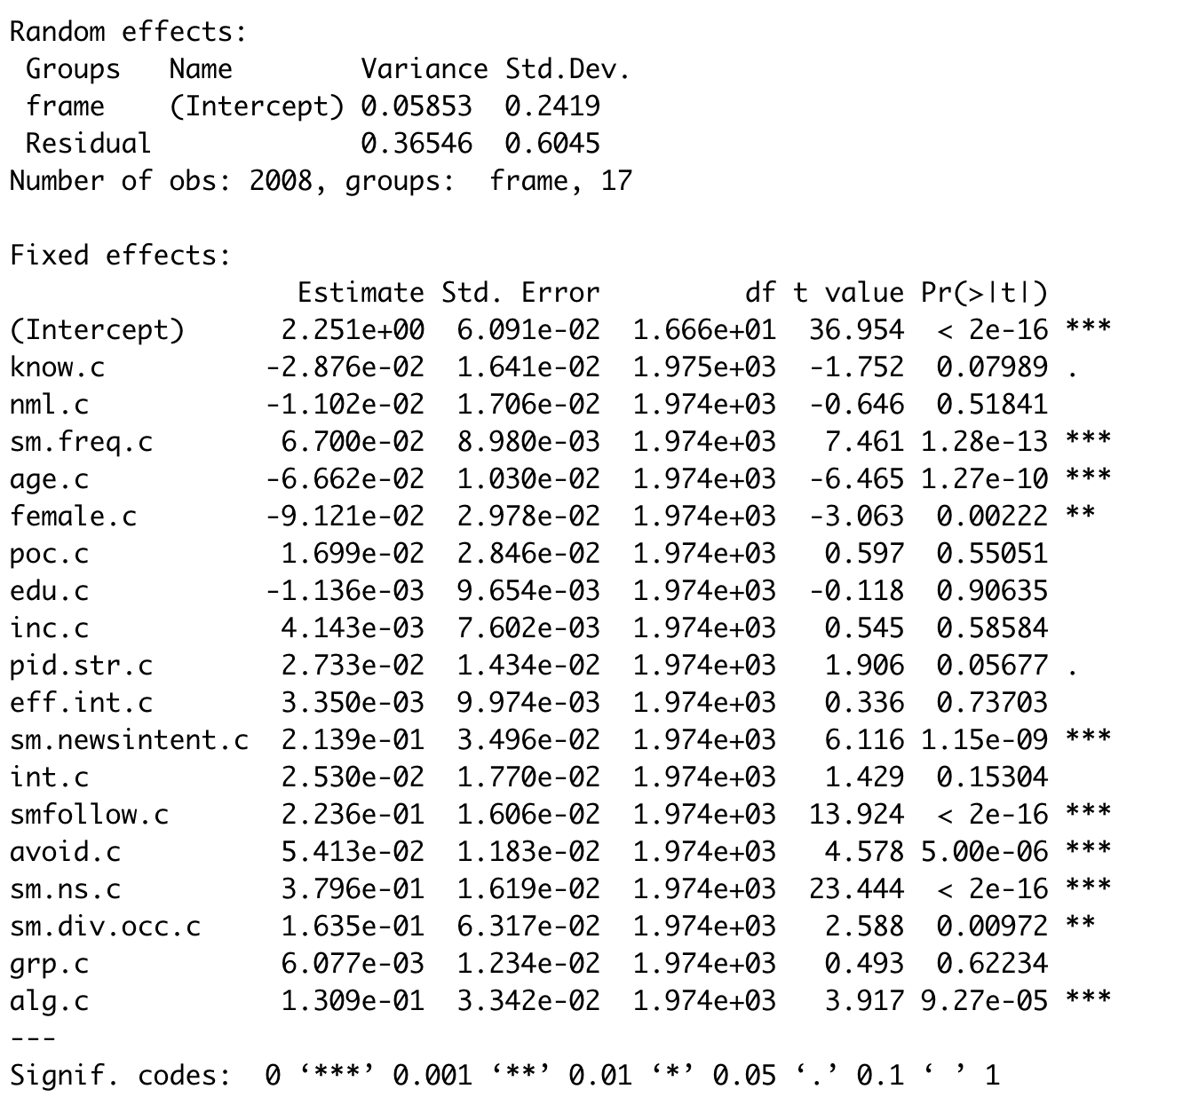

**Model 4: Outcome = news engagement**

**MLM used, DV varies across waves**

**Subset of respondents who use social media news**

**Significant predictors include: news media literacy, race, internal efficacy, purposeful news use, interest, following accounts for news, network size, group membership, and algorithmic categorization**

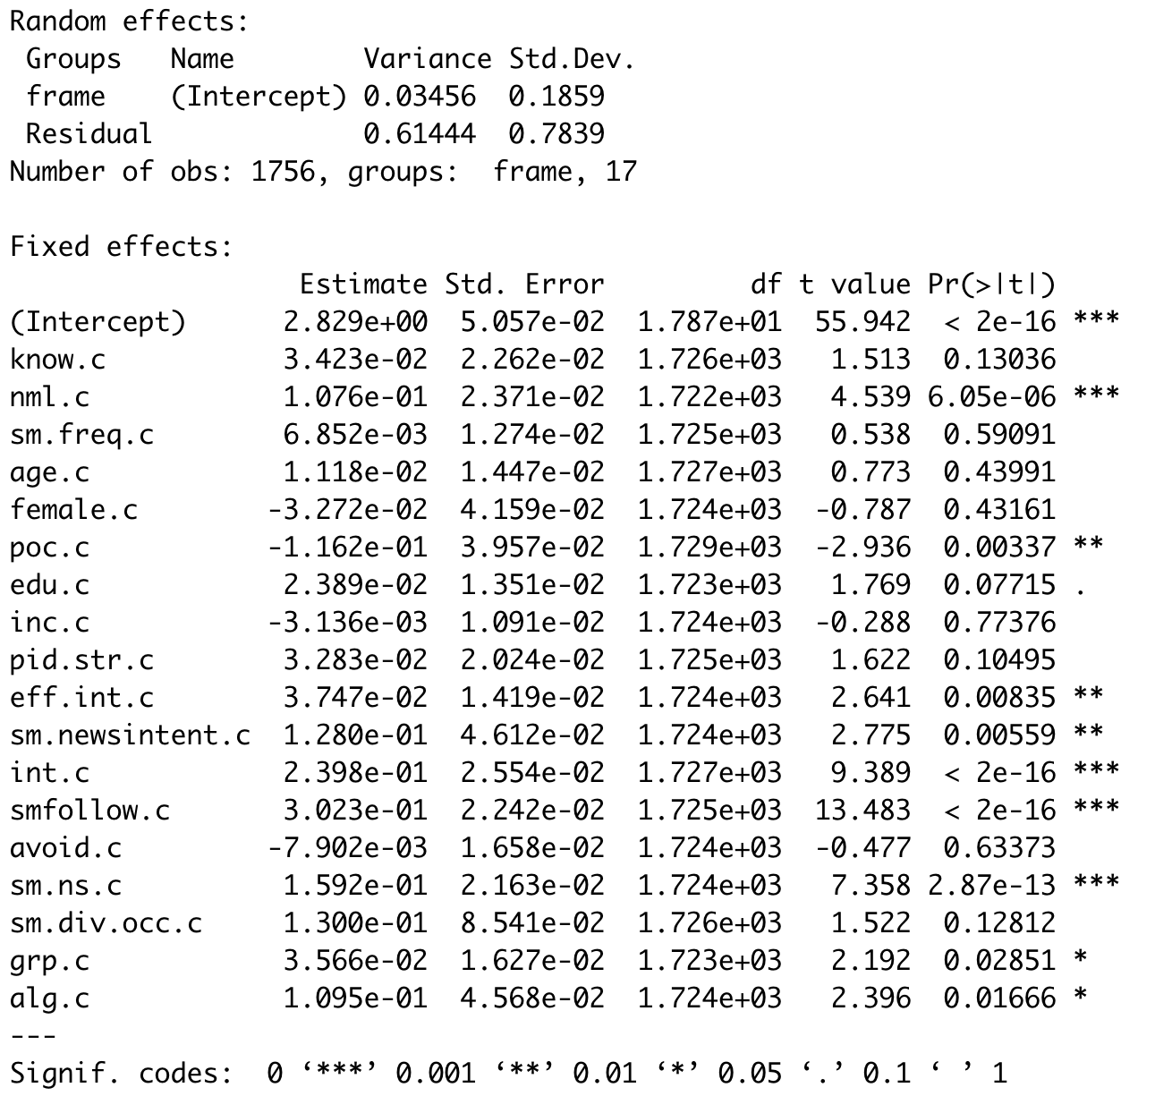

**State Models**

**Model 1: Outcome = story recall (real news, not fake news)**

**MLM used, DV varies across waves**

**Includes level 2 predictors (engagement, net_sent, topic_freq)**

**Significant predictors include: purposefully seeking story, perceived credibility of story, active curation**

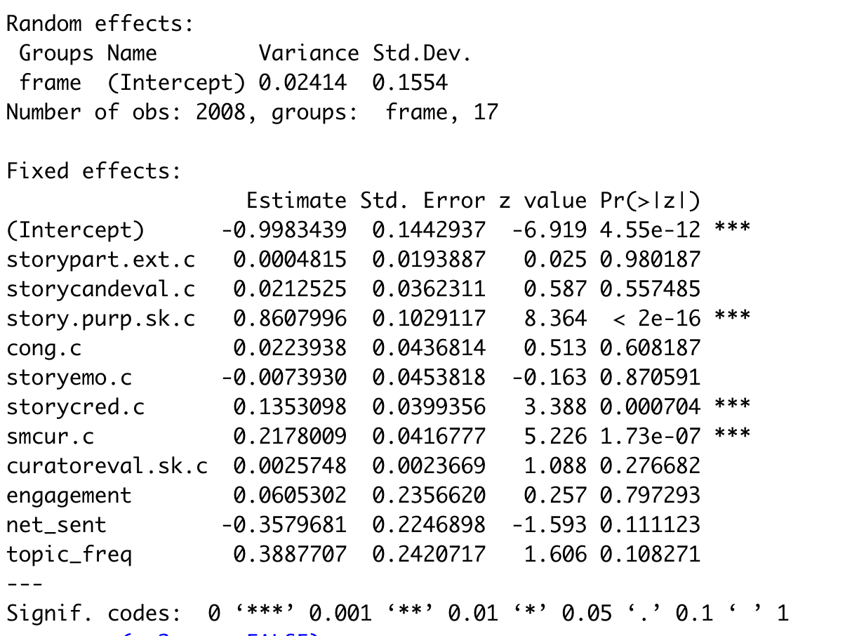

**Model 6: Outcome = story engagement**

**MLM used, DV varies across waves**

**Includes level 2 predictors (engagement, net_sent, topic_freq)**

**Subset of respondents who recalled story**

**Significant predictors include: perceived relevance of story for evaluating candidates, purposefully seeking story, emotional reaction to story, active curation, positive evaluation of curators**

